**P.1 READING LESSON NOTES FOR TERM II 2020**

|  |  |  |  |  |
| --- | --- | --- | --- | --- |
| **Date** | **Class** | **Subject** | **Time** | **No of pupils** |
|  |  |  |  |  |

***THEME: WEATHER***

***SUB – THEME: ELEMENTS OF WEATHER***

***CONTENT: /Oa/ Sound***

*Boat goal soap loaf oats board moan croak*

*Roar load loan goat float raincoat oak*

*Cupboard coat toad road foal coast*

*Coal roast*

***Sentences***

1. *My father has many cows and goats.*
2. *He left his coat inside the boat.*
3. *His brother likes roast meat.*
4. *A lion can roar very loudly.*
5. *The goal keeper ate two toasts*
6. *Go to the road and bring the board*
7. *The goat is on the raod.*

***Exercise***

1. *Listen and write*
2. *Make correct sentences using the words below*
3. *Boat*
4. *Cupboard*
5. *Coat*
6. *Soap*
7. *Goat*
8. *Blend the words below*

*Coal*

*Road*

*Loan*

*Loaf*

1. *Join and form words*

*s p 1. ______________________*

*c oa t 2.______________________*

*g l 3.______________________*

|  |  |  |  |  |
| --- | --- | --- | --- | --- |
| **Date** | **Class** | **Subject** | **Time** | **No of pupils** |
|  |  |  |  |  |

***THEME: WEATHER***

***SUB – THEME: ELEMENTS OF WEATHER***

***CONTENT: ACTUAL READING***

|  |  |  |  |  |
| --- | --- | --- | --- | --- |
| **Date** | **Class** | **Subject** | **Time** | **No of pupils** |
|  |  |  |  |  |

**THEME : Weather**

**SUB THEME : Elements and types of weather.**

**COMPETENCES : Read the vocabulary related to the theme.**

**: Spell the given vocabulary**

**: Fill in the missing letters**

**CONTENT :**

sun rainfall wind clouds

sunshine rain blows cover

shine blowing raining covering

shinning sunny rainy windy cloudy

1. 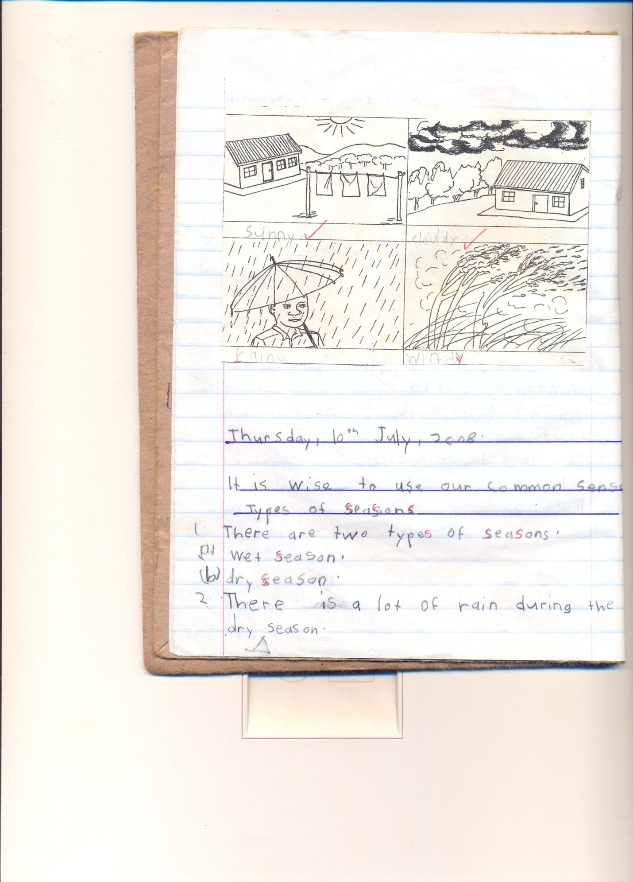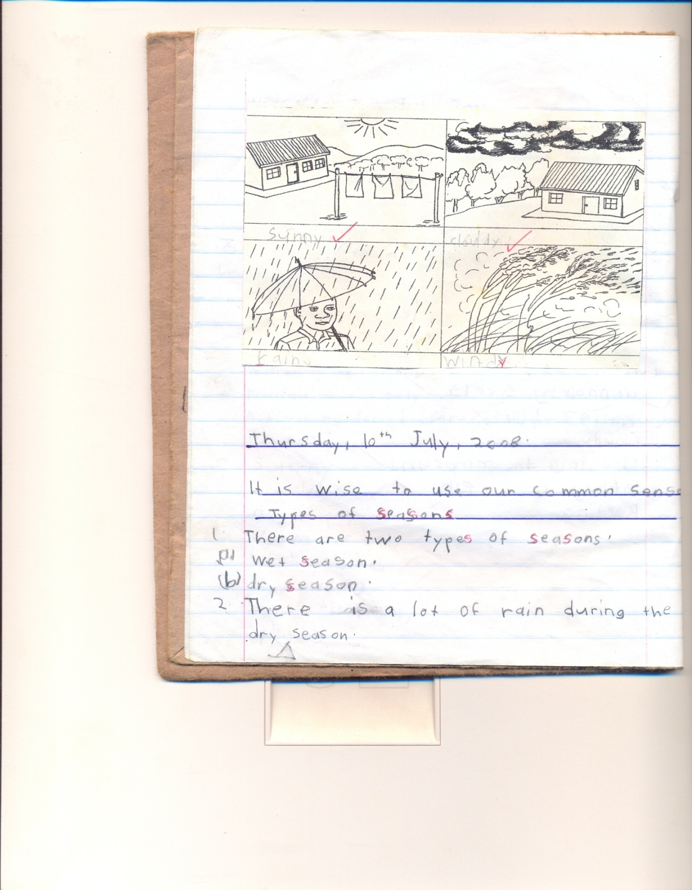Name these of weather



_______________

____________ ___________ _______

1. Listen and write.
2. Fill in the missing letters

su__shine ra__nfall wi__d c__ver

1. Read these

The wind is blowing.

sunshine gives us warmth.

Nimbus clouds gives us rainfall.

|  |  |  |  |  |
| --- | --- | --- | --- | --- |
| **Date** | **Class** | **Subject** | **Time** | **No of pupils** |
|  |  |  |  |  |

**THEME : Weather**

**SUB THEME : Elements and types of weather.**

**COMPETENCES : Read the vocabulary related to the theme.**

**: Spell the given vocabulary**

**: Fill in the missing letters**

On Tuesday morning, Joseph was going to school and the clouds were dark in the sky.

The wind started blowing and carried many things up in the sky.

It started raining and Joseph put on his umbrella and went to school.

As Joseph was in class, it started shinning outside.

**Questions**

1. What is the title of the story?
2. Write the title of the story
3. On which day did Joseph go to school?
4. What is the name of the boy in the story
5. Where was Joseph going?

|  |  |  |  |  |
| --- | --- | --- | --- | --- |
| **Date** | **Class** | **Subject** | **Time** | **No of pupils** |
|  |  |  |  |  |

***THEME: WEATHER***

***SUB – THEME: ELEMENTS OF WEATHER***

***CONTENT: A passage***

***Elements of weather***

|  |  |  |  |  |
| --- | --- | --- | --- | --- |
| **Date** | **Class** | **Subject** | **Time** | **No of pupils** |
|  |  |  |  |  |

**THEME : Weather**

**SUB THEME : Types of weather**

**COMPETENCES : Read the given vocabulary correctly**

**: Spell them correctly.**

**: Write / Name and draw the elements of weather**

**CONTENT : Types of weather**

sunny cloudy

windy rainy

wind blows / blowing _ windy

clouds cover/ covering _ cloudy

rain raining/ rain _ rainy

sun shines/ shinning _ sunny

**Read sentences**

1. The wind is blowing and brings a *windy* type of weather.
2. Rain gives us water and bring a rainy type of weather
3. Clouds are up in the sky and brings us a cloudy weather.

**Exercise.**

1. Fill in the missing letters

s__nny cl__uds ra__ny w__ndy

1. Name the types of weather
2. Re – write correctly

iwnd_____________ olbw __________ nsu ______

terwa ___________

|  |  |  |  |  |
| --- | --- | --- | --- | --- |
| **Date** | **Class** | **Subject** | **Time** | **No of pupils** |
|  |  |  |  |  |

***THEME: WEATHER***

***SUB – THEME: ELEMENTS OF WEATHER***

***CONTENT: ACTUAL READING***

|  |  |  |  |  |
| --- | --- | --- | --- | --- |
| **Date** | **Class** | **Subject** | **Time** | **No of pupils** |
|  |  |  |  |  |

**THEME : Weather**

**SUB THEME : Elements and types of weather**

**CONTENT : Sound/o – e/**

**Words**

*Bone close smoke done home rope hope joke molehill*

*Spoke tone phone sole broke hole note stone doze*

*Whole froze nose some stole home made flag pole*

*Alone broken open cone vote woven*

***Sentences***

1. *Sam broke his leg.*
2. *I can see some smoke from the chimney.*
3. *Mary has a tone dress.*
4. *The minster has a big nose*
5. *That is my mother’s phone*
6. *The thief stole a broken pole*
7. *We have ropes at home*
8. *The boy stoned his nose*

***Exercise***

1. *Listen and write*

*Sentence*

1. *Fill in the missing letters.*

*b __ne sm __ke n ___se s __me*

*br __ke d __ne*

1. *Draw pictures for the small*

***/h/***

***/tr/***

***/a/***

***/st/***

1. *Make correct sentences using these words*

*water*

*wind*

*fire*

|  |  |  |  |  |
| --- | --- | --- | --- | --- |
| **Date** | **Class** | **Subject** | **Time** | **No of pupils** |
|  |  |  |  |  |

***THEME: WEATHER***

***SUB – THEME: ELEMENTS OF WEATHER***

***CONTENT: A passage***

***Elements of weather***

On Tuesday morning Joseph was going to school and the clouds were dark in the sky.

The wind started blowing and carried many things up in the sky.

It started raining and Joseph put on his umbrella and went to school.

As Joseph was in class, it started shinning out side.

**Questions**

1. What is the title of the passage?
2. On which day did Joseph go to school?
3. Who is the boy in the story?
4. Mention two things we use when it is raining
5. Write the title of the passage

|  |  |  |  |  |
| --- | --- | --- | --- | --- |
| **Date** | **Class** | **Subject** | **Time** | **No of pupils** |
|  |  |  |  |  |

***THEME: WEATHER***

***SUB – THEME: ELEMENTS OF WEATHER***

***CONTENT: ACTUAL READING***

|  |  |  |  |  |
| --- | --- | --- | --- | --- |
| **Date** | **Class** | **Subject** | **Time** | **No of pupils** |
|  |  |  |  |  |

**THEME : Weather**

**SUB THEME : Elements and types of weather**

**CONTENT : /oe/ sound**

***Words with /oe/ sound***

*hoe toe Joel Joe woe*

*goes doe foe does*

*toes poem poetry*

*mangoes*

***Sentences***

1. ***Tom cut his toe with a hoe.***
2. ***Joel goes to school every day***
3. ***He likes mangoes***
4. ***What is the poem about?***
5. ***Joe has mangoes***

***Exercise***

1. ***Listen and write***
2. ***Fill in the missing letters***

**g-es t-es h-e mang-es**

1. *Make sentences using the words below*
2. ***Mangoes***
3. ***Hoe***
4. ***Toes***

|  |  |  |  |  |
| --- | --- | --- | --- | --- |
| **Date** | **Class** | **Subject** | **Time** | **No of pupils** |
|  |  |  |  |  |

***THEME: WEATHER***

***SUB – THEME: ELEMENTS OF WEATHER***

***CONTENT: ACTUAL READING***

|  |  |  |  |  |
| --- | --- | --- | --- | --- |
| **Date** | **Class** | **Subject** | **Time** | **No of pupils** |
|  |  |  |  |  |

**THEME : Weather**

**SUB THEME : Effects and management of weather**

**CONTENT : /ow/ sound**

***Words***

*blow below crow own cow town drown bowl*

*elbow arrow fellow follow now flower slow slowest*

*grow know low show owner pillow sow bow*

*window snow bow brown fellow glow rain bow lowest*

*tower vowel reward*

***Sentences***

1. *The man uses a bow and arrow for hunting.*
2. *Strong wind can blow a roof off.*
3. *Some farmers grow cash crops.*
4. *The small girl followed her sister to school.*
5. *Throw the bowl of rotten eggs away.*
6. *Bring that flower now*
7. *Who owns this pillow?*

***Exercise***

1. *Fill in****/ow/*** *sound and read*

***bl __ __n bel __***

***sh __ wind__***

1. ***Join and form words***

***gr***

*arr ow*

*sn*

*sh*

1. ***Listen and write***

|  |  |  |  |  |
| --- | --- | --- | --- | --- |
| **Date** | **Class** | **Subject** | **Time** | **No of pupils** |
|  |  |  |  |  |

***THEME: WEATHER***

***SUB – THEME: ELEMENTS OF WEATHER***

***CONTENT: ACTUAL READING***

|  |  |  |  |  |
| --- | --- | --- | --- | --- |
| **Date** | **Class** | **Subject** | **Time** | **No of pupils** |
|  |  |  |  |  |

**THEME : Weather**

**SUB THEME : Effects and management of weather**

**CONTENT : weather**

*Once upon a time, there lived Mr. Kasasa and his wife. They planned to do some work on the farm. As they were setting to move the clouds covered the sky and it rained heavily for two hours. The wind started blowing and everything was dismantled. They failed to do their work for the whole day.*

***Questions***

1. *What is the title of the story?*
2. *How many people are in the story?*
3. *Write down the four elements of weather.*
4. *Give two things we use on a rainy day*

*______________ and _______________*

1. *Draw rain*

|  |  |  |  |  |
| --- | --- | --- | --- | --- |
| **Date** | **Class** | **Subject** | **Time** | **No of pupils** |
|  |  |  |  |  |

**THEME : Weather**

**SUB THEME : Effects and management of weather**

**CONTENT : /nk/ sound**

***Words***

*Inkpot ankle bank blink sank ink kink blank pink*

*Money donkey sunk tinker thank drink tinkle drank*

*Wrinkle sink rank monk plunk*

*Think sunking*

***Sentences***

1. *There is an inkpot in the bank.*
2. *My grandmother has wrinkles.*
3. *Donkeys and monkeys are animals*
4. *She has a wound on her ankle*
5. *That monkey has wrinkles*
6. *The inkpot is in the bank*

***Exercise***

1. *Listen and write.*
2. *Read and draw.*
3. *That is my grandmother*
4. *An inkpot is on the table*
5. *The monkey is on the tree*
6. *That is my mother*
7. *Write words with the given syllables*

*ba*

*ca*

*ma*

*be*

|  |  |  |  |  |
| --- | --- | --- | --- | --- |
| **Date** | **Class** | **Subject** | **Time** | **No of pupils** |
|  |  |  |  |  |

***THEME: WEATHER***

***SUB – THEME: ELEMENTS OF WEATHER***

***CONTENT: ACTUAL READING***

|  |  |  |  |  |
| --- | --- | --- | --- | --- |
| **Date** | **Class** | **Subject** | **Time** | **No of pupils** |
|  |  |  |  |  |

**THEME : Weather**

**SUB THEME : Effects and management of weather**

**CONTENT : /mb/ sound**

**Words**

*Lamb tomb comb bomber timber number umbrella*

*Climb dumb limb climber humble assemble member*

*Climbing thumb plumber climbed bomb symbol assembly*

*Womb climbing*

***Sentences***

1. *A lamb is a baby sheep*
2. *My thumb has a bandage*
3. *The man was deaf and dumb.*
4. *We comb our hair every day.*

*Exercise*

1. *Listen and write*
2. *Fill in the missing letters*

*T __mb la __b c __mb*

*Cl __mb b __mb thu __b*

1. *Make sentences using the given words*

*Thumb*

*Combing*

*Climbed*

*Lamb*

|  |  |  |  |  |
| --- | --- | --- | --- | --- |
| **Date** | **Class** | **Subject** | **Time** | **No of pupils** |
|  |  |  |  |  |

***THEME: WEATHER***

***SUB – THEME: ELEMENTS OF WEATHER***

***CONTENT: ACTUAL READING***

|  |  |  |  |  |
| --- | --- | --- | --- | --- |
| **Date** | **Class** | **Subject** | **Time** | **No of pupils** |
|  |  |  |  |  |

**THEME : Weather**

**SUB THEME : Effects and management of weather**

**CONTENT : /mp/ sound**

*Lamp ramp pump hump example tempt impact impart simple*

*Jump dump stamp mump complete*

*Simple compose compare improve*

*Important import empire empty*

*Empathy sympathy*

***Sentences***

1. *Can you jump over that lamp.*
2. *Stamp that letter before you send it*
3. *There are many humps in Mpererwe.*
4. *Compare the two examples*
5. *He dumped a bomb near our house.*

*Exercise*

1. *Listen and write*
2. *Re – write the words correctly*

*mpju ____*

*mpsta ____*

*mpla____*

*ainr___*

*terwa____*

*nsu ___*

|  |  |  |  |  |
| --- | --- | --- | --- | --- |
| **Date** | **Class** | **Subject** | **Time** | **No of pupils** |
|  |  |  |  |  |

***THEME: WEATHER***

***SUB – THEME: ELEMENTS OF WEATHER***

***CONTENT: ACTUAL READING***

|  |  |  |  |  |
| --- | --- | --- | --- | --- |
| **Date** | **Class** | **Subject** | **Time** | **No of pupils** |
|  |  |  |  |  |

**THEME : Accidents and safety**

**SUB THEME : Accidents and safety at home**

**COMPETENCES : Reading the words**

**: Spell the words correctly**

**: Constructing sentences**

**Read these words**

**Things which can cause accidents**

Pin thorns

Knife fire

razorblade

broken glass, needle, sharp, hurt, tall, burn, cat, fall

**Sentences**

Never play with sharp things

Sarah has stepped on a pin.

The snake has bitten the boy.

Kato has cut himself with a knife.

**Exercise**

1. Fill in the missing letters

snak__ n__edle ti__e kn__fe

r__zorbl__de po__son

1. Construct sentences using;-

burn fall cut poison

|  |  |  |  |  |
| --- | --- | --- | --- | --- |
| **Date** | **Class** | **Subject** | **Time** | **No of pupils** |
|  |  |  |  |  |

***THEME :* Accidents and safety**

**SUB THEME : Accidents and safety at home**

***CONTENT: ACTUAL READING***

|  |  |  |  |  |
| --- | --- | --- | --- | --- |
| **Date** | **Class** | **Subject** | **Time** | **No of pupils** |
|  |  |  |  |  |

**THEME : Accidents and safety**

**SUB THEME : Accidents and safety at home**

**CONTENT : Reading the passage about accidents**

***ALI AND HIS FRIENDS***

*One day, Musa was going to play with his friends and saw a ripe mango on the tree.*

*He climbed on a branch and it broke.*

*He fell down and broke his arm.*

*He was taken to the hospital*

*Questions*

1. *Write the little of the story*
2. *What happened to Musa?*
3. *Where was he taken after breaking his arm?*
4. *Who treats sick people?*
5. *Draw Musa falling off from the tree*

|  |  |  |  |  |
| --- | --- | --- | --- | --- |
| **Date** | **Class** | **Subject** | **Time** | **No of pupils** |
|  |  |  |  |  |

***THEME :* Accidents and safety**

**SUB THEME : Accidents and safety at home**

***CONTENT: ACTUAL READING***

|  |  |  |  |  |
| --- | --- | --- | --- | --- |
| **Date** | **Class** | **Subject** | **Time** | **No of pupils** |
|  |  |  |  |  |

**THEME : Accidents and safety**

**SUB THEME : Accidents and safety at home**

**CONTENT : /nt/ sound**

*Words*

*enter internal introduction want cent saint went*

*Interest entire entry tint plant rent elephant*

*Antelope ant aunt bent pant hunt lent*

*Anthill Antony mountain blunt burnt*

*Account amount*

***Sentences***

1. *That is an antelope.*
2. *My aunt has entered the house*
3. *That book is interesting.*
4. *I can see a mountain*
5. *Give me that amount of money*
6. *The hunter burnt the plant*

*Exercise*

1. *Listen and write.*
2. *Read and draw*

*Aunt anthill mountain antelope*

1. *Make sentences*

*Family*

*Mountain*

*Mother*

*Razorblade*

|  |  |  |  |  |
| --- | --- | --- | --- | --- |
| **Date** | **Class** | **Subject** | **Time** | **No of pupils** |
|  |  |  |  |  |

***THEME :* Accidents and safety**

**SUB THEME : Accidents and safety at home**

***CONTENT: ACTUAL READING***

|  |  |  |  |  |
| --- | --- | --- | --- | --- |
| **Date** | **Class** | **Subject** | **Time** | **No of pupils** |
|  |  |  |  |  |

**THEME : Living together**

**SUB THEME : The family**

**COMPETENCES : Read the vocabulary related to the theme**

**FAMILY MEMBERS**

Father mother sister brother

grandmother grandfather uncle

aunt nephew baby niece

**Construct sentences using the given words**

nephew family mother father

1. Listen and write
2. Fill in the missing letters

f__ther moth__r br__ther s__ster

|  |  |  |  |  |
| --- | --- | --- | --- | --- |
| **Date** | **Class** | **Subject** | **Time** | **No of pupils** |
|  |  |  |  |  |

**THEME : Living together**

**SUB THEME : The family**

**COMPETENCES : Read the vocabulary related to the theme**

**THE FAMILY**

My name is Achieng

I have three sisters, Jesca, Jessy and Jacky.

We help our parents to do some domestic work.

My sisters sweep the compound and I go to fetch water from the well.

I love my family.

**Questions**

1. What is the title of the story?
2. Who are Achieng’s sisters?
3. How many sister does she have?
4. Write down the names of Achieng’s sisters
5. Draw Achieng carry a bucket of water

|  |  |  |  |  |
| --- | --- | --- | --- | --- |
| **Date** | **Class** | **Subject** | **Time** | **No of pupils** |
|  |  |  |  |  |

**THEME : Living together**

**SUB THEME : The family**

**CONTENT : /sl/ sound**

***Words***

*Slam sled slit slope slump*

*Slack slot slush slag slid*

*Slow slump slang sliver slate*

*Sleep*

***Sentences***

1. *Dan has a blue and yellow sled.*
2. *Miracle likes to sleep on the grass.*
3. *Joy has a slit on her skirt.*
4. *Tom is going to slash the compound.*
5. *Let us slope down for community work*

*Exercise*

1. *Listen and write*
2. *Re – write the words correctly.*

*Pslee*

*Slsha*

*Stil*

1. *Make sentences.*

* ______________________________*

**

**

*_________________________*

*____________________________*

|  |  |  |  |  |
| --- | --- | --- | --- | --- |
| **Date** | **Class** | **Subject** | **Time** | **No of pupils** |
|  |  |  |  |  |

**THEME : Living together**

**SUB THEME : The family**

**CONTENT : Actual reading**

|  |  |  |  |  |
| --- | --- | --- | --- | --- |
| **Date** | **Class** | **Subject** | **Time** | **No of pupils** |
|  |  |  |  |  |

**THEME : Living together**

**SUB THEME :**

**COMPETENCES : Reading the given vocabulary**

**: Drawing and naming the garden tools**

**: Reading names of garden tools.**

slasher hoe rake

spade basket knife

panga fork wheelbarrow

watering can axe

**Exercise**

1. Listen and write
2. Fill in the missing letters

p__nga kn__fe r__ke

ho__ sp__de w__teringc__n

b__sket sl__sher f__rk

|  |  |  |  |  |
| --- | --- | --- | --- | --- |
| **Date** | **Class** | **Subject** | **Time** | **No of pupils** |
|  |  |  |  |  |

**THEME : Living together**

**SUB THEME : The family**

**CONTENT : Actual reading**

|  |  |  |  |  |
| --- | --- | --- | --- | --- |
| **Date** | **Class** | **Subject** | **Time** | **No of pupils** |
|  |  |  |  |  |

**THEME : Living together**

**SUB THEME :**

**CONTENT : /cr/ Sound**

*1. Identify the letter symbol and tell its name.*

*2. Introduce the sound with a song/rhyme/ story.*

*3. Teacher will guide the learners to identify the repeated sound.*

*4. Teacher will relate the sound to the picture and the picture to the word.*

*5. Teacher will allow the children to practice the sound and words many times.*

*Teacher will develop the word family for the sound.*

*Crack* ***cr*** *cross*

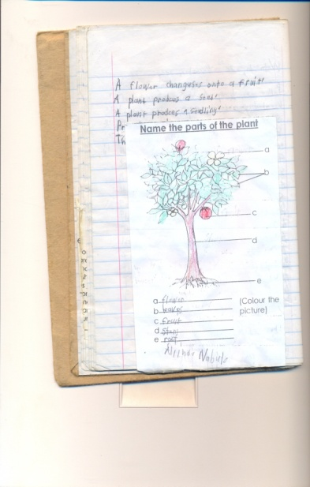

*crop*

*Crested crane*

|  |  |  |  |  |
| --- | --- | --- | --- | --- |
| *cru* | *cro* | *cri* | *cra* | *cre* |
| *Crush*  *Cruel*  *Crucify*  *Crude*  *Crusade*  *crumble* | *Cross*  *Crown*  *Crop*  *Crow*  *Crooked*  *crocodile* | *Crip*  *Crime*  *Crib*  *Cripple*  *Cricket*  *Criminal*  *crisp* | *Crack*  *Craft*  *Crane*  *Cram*  *Crayon*  *Crash*  *Crawls*  *cradle* | *Cred*  *Cream*  *Creep*  *Create*  *Screw*  *Creed*  *Crested*  *Crowd*  *croak* |

***Sentences***

*1. Jesus was crucified on the cross.*

*2. A creeping crop is good.*

*3.God created the crested cane etc.*

*EXCRISE*

1. *Listen and write*
2. *Read and draw*
3. *Cross*
4. *Crested crane*
5. *Crayon*
6. *Make sentences*

*Cross*

*Crack*

*Craft*

*cruel*

|  |  |  |  |  |
| --- | --- | --- | --- | --- |
| **Date** | **Class** | **Subject** | **Time** | **No of pupils** |
|  |  |  |  |  |

**THEME : Living together**

**SUB THEME : The family**

**CONTENT : Actual reading**

|  |  |  |  |  |
| --- | --- | --- | --- | --- |
| **Date** | **Class** | **Subject** | **Time** | **No of pupils** |
|  |  |  |  |  |

**THEME : Living together**

**SUB THEME :**

**CONTENT : /cl/ sound**

**Words**

*Clap class clan cloth clot clan clarify*

*Clinic close classic client clay cloud clement climate*

*Clock clever clip clear clump claim climb climax*

***Sentences***

1. *The boys clapped their hands.*
2. *There is a clock on the table.*
3. *She went to the clinic in the morning*
4. *He is in primary one class.*
5. *The client was clever.*

*Exercise*

1. *Listen and write*
2. *Fill in the missing letters*

*Cl __p cl __ss cl __th cl __se*

1. *Make sentences for the pictures*

*Class*

*Cloth*

*Clay*

*Clinic*

|  |  |  |  |  |
| --- | --- | --- | --- | --- |
| **Date** | **Class** | **Subject** | **Time** | **No of pupils** |
|  |  |  |  |  |

**THEME : Living together**

**SUB THEME : The family**

**CONTENT : Actual reading**

|  |  |  |  |  |
| --- | --- | --- | --- | --- |
| **Date** | **Class** | **Subject** | **Time** | **No of pupils** |
|  |  |  |  |  |

**THEME : Food and Nutrition**

**SUB THEME : Names and sources of food.**

**CONTENT : /fr/ sound**

***Words***

*Frog front from franc fragile front fridge*

*France froze frolic fraction fracture fresh fruit*

*Frisk fritter frantic freedom freeze*

*Frock frill frit Fredrick*

*Friends fry free fracture*

***Sentences***

1. *Franc is from France*
2. *Get those books from franc*
3. *France is a good country*
4. *Fredrick has many friends*
5. *The frog is in front of the cup*

*Exercise*

1. *Listen and write*
2. *Join to from one word.*

*Fro – g*

*Fro – nt*

*Fro – m*

1. *Blend the words below*

*Free*

*Friends*

*freedom*

|  |  |  |  |  |
| --- | --- | --- | --- | --- |
| **Date** | **Class** | **Subject** | **Time** | **No of pupils** |
|  |  |  |  |  |

**THEME : Food and Nutrition**

**SUB THEME : Names and sources of food.**

**CONTENT : Actual Reading**

|  |  |  |  |  |
| --- | --- | --- | --- | --- |
| **Date** | **Class** | **Subject** | **Time** | **No of pupils** |
|  |  |  |  |  |

**THEME : Food and Nutrition**

**SUB THEME : Names and sources of food.**

**CONTENT : /fl/ sound**

***Words***

*Flower fly flag flat float flash flamingo flood*

*Flask flit flock flank flight flour flower florist*

*Florist flatten flutter flog flow flew*

*Fled flew fluent flu*

***Sentences***

1. *They are playing on a flat field*
2. *Our national flag has flowers*
3. *That flask has nice flowers*
4. *The flag is on the flat*

*Exercise*

1. *Listen and write*
2. *Read and draw*

*Flower*

*Flag*

*Flat*

*Flask*

1. *Make sentences using the given words.*
2. *Flag*
3. *Flower*
4. *Friend*
5. *Play*

|  |  |  |  |  |
| --- | --- | --- | --- | --- |
| **Date** | **Class** | **Subject** | **Time** | **No of pupils** |
|  |  |  |  |  |

**THEME : Food and Nutrition**

**SUB THEME : Names and sources of food.**

**CONTENT : actual reading**

|  |  |  |  |  |
| --- | --- | --- | --- | --- |
| **Date** | **Class** | **Subject** | **Time** | **No of pupils** |
|  |  |  |  |  |

**THEME : Food and Nutrition**

**SUB THEME : Names and sources of food.**

**COMPETENCES : Reading the names of common foods.**

**: Spell the words given**

**: Read and draw**

**Content : Potatoes water banana millet peas**

**beans groundnuts sim sim**

|  |  |  |  |  |
| --- | --- | --- | --- | --- |
| **Date** | **Class** | **Subject** | **Time** | **No of pupils** |
|  |  |  |  |  |

**THEME : Food and Nutrition**

**SUB THEME : Sources of common foods.**

**Vocabulary to read**

garden water/lake market

animal plants shops

**Sentences**

We buy simsim from the shops.

We grow crops in the garden.

We get fish from the water.

We get meat from animals.

**Exercise**

Read and draw the sources of food.

|  |  |  |  |  |
| --- | --- | --- | --- | --- |
| **Date** | **Class** | **Subject** | **Time** | **No of pupils** |
|  |  |  |  |  |

**THEME : Food and Nutrition**

**SUB THEME : Names and sources of food.**

**CONTENT : actual reading**

|  |  |  |  |  |
| --- | --- | --- | --- | --- |
| **Date** | **Class** | **Subject** | **Time** | **No of pupils** |
|  |  |  |  |  |

**THEME : Food and Nutrition**

**SUB THEME : Uses of food**

“Pr” Sound

president prick pray

present price praise

pretty proud primary

practice print prison

present prove pretend print problem

private prepare prison proud press

prey price prefer preach pride profit

Sentences

The president is proud .

Please print properly.

Prossy likes to pray.

I am present sir.

The needle pricked me.

The priest is praying for us.

**Exercise**

1. Listen and write
2. Construct sentences using

* Primary
* Pray
* President

|  |  |  |  |  |
| --- | --- | --- | --- | --- |
| * **Date** | **Class** | **Subject** | **Time** | **No of pupils** |
|  |  |  |  |  |

**THEME : Food and Nutrition**

**SUB THEME : Names and sources of food.**

**CONTENT : actual reading**

|  |  |  |  |  |
| --- | --- | --- | --- | --- |
| **Date** | **Class** | **Subject** | **Time** | **No of pupils** |
|  |  |  |  |  |

**STEPS**

*i) Identify the letter symbol and tell its name.*

*ii) Introduce a sound with a song/rhyme/story.*

*iii) The teacher will guide the learners to identify the repeated sound.*

*iv) Teacher will relate the sound to the picture and picture to the words.*

***pl***

*v) Children will practice the sound and words several times.*

*Teacher will develop the word family for the sound.*

|  |  |  |  |  |
| --- | --- | --- | --- | --- |
| *ple* | *plu* | *pli* | *pla* | *plo* |
| *Plead*  *Plenty*  *Plain*  *Place*  *Play plate*  *Plane* | *Plug*  *Plumber*  *pludence* | *Poink* | *Place*  *Plant*  *Plastic*  *play* | *Plot*  *Plural* |

***Sentences***

*1. The plumber used plastic pipes.*

*2. Plant those plants in that place.*

*3. Prudence wants to play with plastic things.*

*4. Plats are in plenty.*

***Activity***

*1. Listen and write.*

*2. Make sentences using the given words*

*Play plant place plastic*

*3. Blend these words.*

*Plenty plumber plant*

|  |  |  |  |  |
| --- | --- | --- | --- | --- |
| **Date** | **Class** | **Subject** | **Time** | **No of pupils** |
|  |  |  |  |  |

**THEME : Food and Nutrition**

**SUB THEME : Names and sources of food.**

**CONTENT : Actual reading**

|  |  |  |  |  |
| --- | --- | --- | --- | --- |
| **Date** | **Class** | **Subject** | **Time** | **No of pupils** |
|  |  |  |  |  |

**THEME : Food and Nutrition**

**SUB THEME : Names and sources of food.**

**CONTENT : A DIALOGUE ABOUT FOOD**

**Semeo:** Hulloa Nadia

**Nadia:** Hullo Semeo

**Semeo:** Did you eat supper?

**Nadia:** Yes, I did

**Semeo:** What type of food did you eat?

**Nadia:** Matoke, rice and fish

**Semeo:** What about you?

**Nadia:** Oh! My friend very many types of food, bananas, Irish potatoes, peas and meat

**Semeo:** Ha! Ha! Ha!

Won’t you fall sick?

**Nadia:** No, that is balanced diet

**Questions**

1. Write the title of the dialogue.
2. Who are the two people talking
3. Give three types of food mentioned in the dialogue
4. How many people are talking in the dialogue?
5. What is the opposite of these words below?

Enemy

Many